# 

**PROJECT REPORT ON LEAVE MANAGEMENT SYSTEM**

**A CASE STUDY OF TANZANIA PUBLIC SERVICE COLLEGE (TPSC)**

**TABORA CAMPAS**

**PREPARED BY**

**ZUHURA P KASAMALA**

**DIT 01/18/T.10**

**NO: 0754507402**

**A PROJECT REPORT PROPOSED IN FULFILLMENT OF REQUIREMENT FOR THE AWARD OF DIPLOMA IN INFORMATION TECHNOLOGY**

**DEPARTMENT OF INFORMATION AND COMMUNICATION TECHNOLOGY OF TANZANIA PUBLIC SERVICE COLLEGE**

**JANUARY 2020**

# CERTIFICATION

Certifies that ZUHURA P KASAMALA candidate whose registration number is DIT 01/18/T.10 is the Diploma of information technology has presented his/her project entitled “LEAVE MANAGEMENT SYSTEM” that as appear on the title page.

Supervisor Name:…………………………………………………………………………..

Signature:……………………………………………………………….

Date:……………………………………………………………………...

# DECLARATION

I ZUHURA P KASAMALA I declare that this project report entitled “LEAVE MANAGEMENT SYSTEM” is the result of my own project except as cited in the references. The report submitted by me as part of award of “Diploma in information technology at Tanzania Public Service College accepted for any Diploma and is not concurrently submitted in candidate of any other diploma.

Name:………………………………………………………………………..

Signature:…………………………………………………………………

Date:……………………………………………………………………….

# LIST OF ABBREVIATIONS

CEO – Chief Executive Officer

JS - JavaScript

LMS – Leave Management System

HTML – HyperText Markup language

RAM – Random Access Memory

PHP – Hypertext Preprocessor

CPU – central processing unit

DBA – Database administration

CSS – Cascading Style sheet

# LIST OF FIGURES AND TABLES

Figure 1: the use case diagram used for collecting requirement………………………………….5

Figure 4.1: show Home page of the system………………………………………………………6

Figure 4.2: Show application leave form………………………………………………………….7

Figure 4.3 Show the registration form………………………………………………………….8

Figure 4.4 show database home…………………………………………………………………8

Table 1: project budget…………………………………………………………………………...9

**ACKNOLEDGEMENT**

I would like to thanks almighty GOD who enable me to complete this report, because without his help am sure that I could not be able to compete this report.

I am appreciate also to my supervisor HAMIS MASHAKA and others my entire family for their big support without forgetting my all classmate for their support.

Moreover I would like to express my sincere thanks to all the academic staffs and all the student of the Tanzania Public Service Collage.

**ABSTRACT**

The project titled “LEAVE MANAGEMENT SYSTEM” have been developed to override the problems prevailing manual system. Also the project explains the whole process like analysis, literature review, requirement, design etc.

This project have a lot of function like to eliminate paperwork, save time on simplifying the work so it can’t take more time moreover it reduce loss of data in an organization.

The project can contain one login form that can be used by two users (normal user and admin) so any person who login in the system he/she can go in their section.

Also the project will allow the admin to add/register new employee in the system and to check all leaves applied and to answer his/her about their leaves. Moreover there was database which store a personal details of the employee for example there was id, username, first name, last name, email, phone, date, date of birth, work, type, and password. Within our database there was two tables which are “alltb” that store all employees that has been registered by admin and “leavm” that store all information about leaves for employees.

**TABLE OF CONTENT**

CERTIFICATION i

DECLARATION ii

LIST OF ABBREVIATIONS iii

LIST OF FIGURES AND TABLES iv

1.0 BACKGROUND OF THE STUDY 1

1.1 INTRODUCTION 1

1.2 PROBLEM STATEMENT 1

1.4 Objectives of the project 2

1.5 Methodology 2

CHAPTER TWO 3

2.0 Introduction 3

2.1 definition 3

CHAPTER THREE 5

3.0 SYSTEM ANALYSIS OF THE SYSTEM 5

CHAPTER FOUR 7

SYSTEM DESIGN AND IMPLEMENTATION 7

4.0 Introduction 7

CHAPTER FIVE 12

CONCLUSION AND RECOMMENDATIONS 12

5.0 CONCLUSION 12

5.1 RECOMMENDATION 12

REFERENCES 13

APPENDIXES 14

APPENDIXES 1: BUDGET ESTIMATION PROJECT 14

**CHAPTER ONE**

## 1.0 BACKGROUND OF THE STUDY

### 1.1 INTRODUCTION

Leave management system means the process of handling leaves and absences due to sickness vacation or other reasons also it can be enable the employees to maintain a record of their leaves as well as make requests for the same within the organization. The employees can apply for leave on leave system, manager will get email or username notification of employees leave application also not as much forward and backward is required when employees can submit requests instantly. Within this title there some words that I can explain. LEAVE means left or go away from, MANAGEMENT means the process of dealing with or controlling things or people. SYSTEM means a collection of elements or components that are organized to form a common purpose.

### 1.2 PROBLEM STATEMENT

In the existing system, leaves are maintained using the attendance register for staff. The staff needs to submit their leaves manually to their respective authorities. This increases the paperwork and maintaining the records becomes tedious. Maintaining notices in the records also increases the paperwork. The main objective of the proposed system is to reduce the paperwork and help in easier record maintenance by having a particular centralized Database System, where Leaves and Notices are maintained. The proposed system modernizes and automates the existing system. It decreases the paperwork and enables easier record maintenance. It also reduces chances of Data loss.

#### SCOPE OF THE PROJECT AND LIMITATION

#### 1.3.1 LIMITATION OF THE PROJECT

This application is used within the organization and not outside. All employees that are be registered by admin are allowed to use this system and not vise verse

#### 1.3.2 SCOPE OF THE PROJECT

The LMS is the system which keeps track of all employees and their information that found within the organization. The system developed in order to simplify some tasks that were performed by the manually system;

registration of new employee

1. Leave application. The system is client database based and there have users, any user has its own passwords and username that can allow to login in the system. User can login and view their information leave in the system. This project deal with leaves. The scope of the system is introducing a new way of applying leaves.

### 1.4 Objectives of the project

#### 1.4.1 General objectives

To design and implement an automated leave management system that can allow employee to apply leave within the organization.

#### 1.4.2 Specific objectives

1. To exchange information within the organization. Example if you want to send the message to CEO that you want to leave, so this project can do this function.
2. To decrease the paperwork and enable the process with efficient, reliable record maintenance by using centralized database.
3. To develop the system that can help all employees and organizational in generally to move from current system to the new system that can reduce data losing.

### 1.5 Methodology

**1.5.1 Interview**

The interview method was used to collect data from the system in order to conduct the project development, the data collected in the project development.

**1.5.2 Observation**

Through this method the leave management system of applying leaves physically is so difficult that’s why I was decided to develop a leave system in order to replace the way of applying leaves in manually.

* + 1. **questionnaire**

in questionnaire method was divided into two parts those are open questionnaire and closed questionnaire. All in all those are used to collect data from the respondent system

# CHAPTER TWO

**LITERATURE REVIEW**

## 2.0 Introduction

In this chapter was include the different explanation definition and their importance of some terms that used to develop this system.

## 2.1 definition

* + 1. **HTML**

HTML stands for Hyper Text Markup Language.HTML is the standard markup language for creating Web pages. HTML describes the structure of a Web page. HTML consists of a series of elements. HTML elements tell the browser how to display the content. HTML elements are represented by tags. HTML tags label pieces of content such as "heading", "paragraph", "table", and so on. Browsers do not display the HTML tags, but use them to render the content of the page

THE BASIC STRUCTURE OF AN HTML DOCUMENT

<!DOCTYPE html>  
<html>  
<head>  
<title>Page Title</title>  
</head>  
<body>  
</body>  
</html>

* + 1. **Importance of html**
* A significant benefit of HTML it is free of charge and no need to install any software.
* HTML is simple to use and understand. and high speed loading time.
* All browsers support HTML.
* Most development tools whatever they are paid or free all support HTML.
  + 1. **PHP**

PHP is an acronym for "PHP: Hypertext Preprocessor". PHP is a widely-used, open source scripting language. PHP scripts are executed on the server

Basic PHP Syntax

A PHP script can be placed anywhere in the document.

A PHP script starts with <?php and ends with ?>:

<?php  
// PHP code   
?>

* + 1. **Importance of PHP**
* PHP used to generate dynamic page content can create, open, read, write, and close files on the server, can collect form data, can send and retrieve cookies, can add, delete, modify data on your database.
  + 1. **DATABASE**

A database is a collection of related data or information that is organized so that it can easily to be accessed. Also a database can be divided into two part which are Server based (Multiuser) and Desktop based (single user). A database also is a back-end of an application. A DBMS receives instruction from a database administrator (DBA).

* + 1. **importance of Database**
* Save time: this is the one of the importance of database. A database it save time like when a user want to enter a specific keywords in order to recall information. The database becomes a more efficient solution than paper files held in a file folder.
* More secured: The database management system can ensure only authorized users are allowed to access the information.
* Modularity: The system can be modified, added, and removed from the distributed database without affecting other modules (system).

# CHAPTER THREE

## 3.0 SYSTEM ANALYSIS OF THE SYSTEM

* 1. **Project plan**

Is the guidelines for the system development including arrange tasks into phases, involve users, develop clearly defined standards etc.

* 1. **Planning**

This was the first method I passed and I spent for one week. Involving reviewing the project request, allocate resources, and to identify project development team and this was a first phase we passed through.

* 1. **Analysis**

Analysis is the process of collecting factual data. In method or phase I can use more time to spent and studied the current system that used the application like Microsoft excel compared to this time that we use the questionnaire, interview, and observation.

* 1. **Designing**

In this method I use two weeks to spent, in this method the user interface was design, specific program like PHP language for the system development, database that will be needed and in database we used mysql.

* 1. **Implementation**

In phase the system was built by writing code in the program used PHP language. Then the system was tested and installed to replace the old system which used paper based system.

**Use case of the system**

database

**figure 1: the use case diagram used for collecting requirement.**

Key

Actor

System boundary

Arrow

# CHAPTER FOUR

## SYSTEM DESIGN AND IMPLEMENTATION

### 4.0 Introduction

Leave management system will make use of the existing web browser such as internet explorer. The user interface of the system shall be designed as shown in the user interface prototypes.

**4.1. Home page**

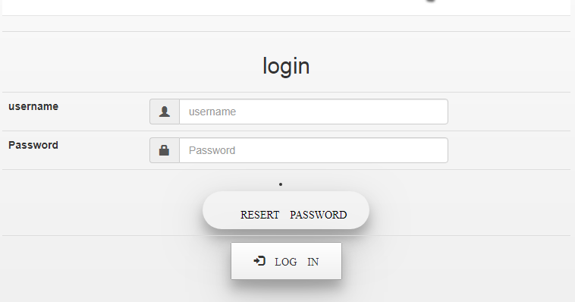

Figure 2: Home page of the system

**4.1.2 Leave application form**

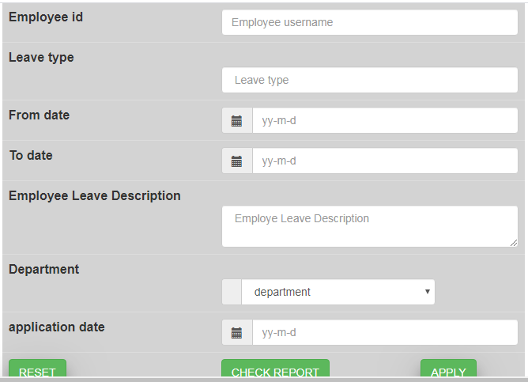

Figure 3: Show application leave form

**4.1.3 Registration form**

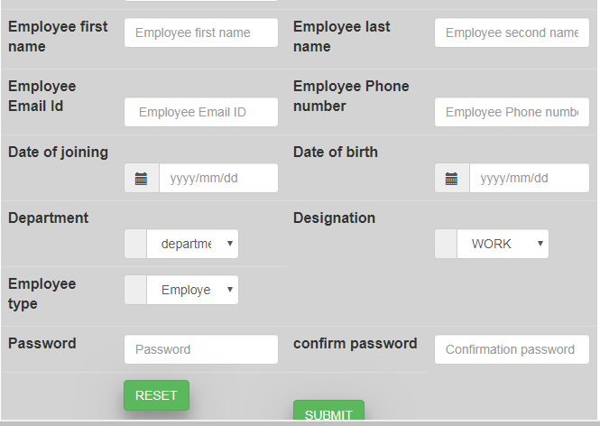

Figure 4: Show the registration form

**4.1.4 Database home**

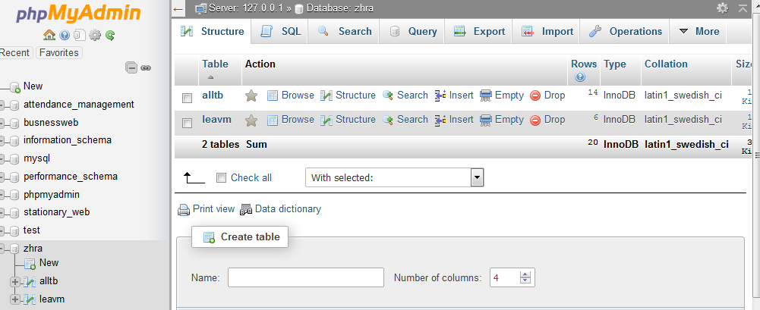

Figure 5: show database home

#### 4.2 IMPLEMENTATION

In this project system there are some codes of PHP, HTML and others. Below are the examples of PHP and HTML codes

**4.2.1 Code**

<?php

error_reporting(0);

session_start();

$id2 = $_SESSION['id'];

$database = mysqli_connect('localhost','root','','zhra');

if (isset($_POST['login'])) {

$comment = $_POST['comment'];

$action = $_POST['active'];

$update = "UPDATE `leavm` SET `coment`='$comment',`status`='$action' WHERE `id`='$id2'";

$up = mysqli_query($database,$update);

?>

<table class="table table-striping" >

<form class="form-control" action="employee.php" method="post">

<tr><td colspan="4"> <h2>Employee login</h2> </td></tr><tr>

<th> username </th> <td><div class="input-group"><span class="input-group-addon"><i class="glyphicon glyphicon-user"></i></span><input type="text" name="username" placeholder="username" class="form-control" style="width: 70%;"></td><td rowspan="4"> <center><li><a href="admin.php" class="button" style="width: 100%; border-radius: 45px;" ><span class="glyphicon glyphicon-go"> ADMIN LOGIN </span></a></li> </center> </td>

#### 4.3 TOOLS USED TO DEVELOP THE LEAVE MANAGEMENT SYSTEM

The leave management system due to their development we use many different tools. Below are the tools used on development;

* Processor: Intel(R) Atom(TM) CPU N270 @1.60GHZ 1.60GHZ
* Installed memory (RAM): 2.00 GB
* System type: 32-bit operating system
* Windows 7Professional Operating System
* Xampp Bitnami 5.5.38-1 1.60GHZ
* Html markup language
* Notepad ++
* Browser
* Php scripting language
* Bootstrap
* Jquery
* Javascript (js)

# CHAPTER FIVE

## CONCLUSION AND RECOMMENDATIONS

### 5.0 CONCLUSION

Leave system it’s very important system for any organization because its reduce time consuming, it reduce paper transmission (movement of paper from one office to another), it reduce paper work. The leave management system deals with the employee registration within the organization, and leave application for the employees. The admin of this system are able to see all leave that are applied by employees and to and to answer all leaves.

Therefore Leave management system is the system that can be enable the employees to maintain a record of their leaves as well as make requests for the same from anywhere. The employees can apply for leave on leave system, manager will get email or username notification of employees leave application also not as much forward and backward is required when employees can submit requests instantly

### 5.1 RECOMMENDATION

I recommend that any organization should have be a leave system that can do functionality within in order to escape with manually system. the system can allow future adjustments to integrate future demands. The project will serve as a knowledge base to other researchers and interested parties. Also it will be used as a template for developing the real database system for Tanzania Public Service Collage. So I hope that the system will help TPSC to minimize the problems that can occur in manual recruitment system . also I commend to government that must make sure that at least all organization’s have this kind so as to control their employee in generally.

# REFERENCES

[1] Adamson and Veronica. (2008). JISC & SCONUL Leave Management Systems Study. Sheffield

[2] UK: Sero Consulting. p. 51. Retrieved on 06 August 2015.

[3]Adomi, E. E., &Anie, S. O. (2006). An Assessment of Computer Literacy Skills of Professionals in Nigerian University libraries. Library Hi Tech News, Vol.23 (2) pp.10-14.

[4]Ashutosh, T and Ashish,S. (2012). Online Leave Management System. IOSR Journal of

Engineering (IOSRJEN). Vol. 2 (2), pp. 180- 186.

[5]http://www.ifla.org/files/hq/papers/ifla75/126-dasgupta-en.pdf.

[6]DeSpautz, Joseph; Kenneth S. Kovacs; Gerhard Werling (2008). GAMP Standards for Validation of Automated Systems. Pharmaceutical Processing. Retrieved 28 February 2012.

# APPENDIXES

## APPENDIXES 1: BUDGET ESTIMATION PROJECT

|  |  |  |
| --- | --- | --- |
| NO | ITEMS | ESTIMATED COST (Tsh) |
| 01 | Pen | 1000 |
| 02 | Laptop-Acer | 250,000 |
| 03 | Materials reviewing | 5000 |
| 04 | Stationery | 7000 |
| 05 | Modem | 40000 |
| 06 | Internet service | 7000 |
| 07 | Binding | 5000 |
|  | TOTAL | Tsh. 315,000 |
|  |

Table 1: project budget